Test Case: tc006_SPX_Dev5_Crear_Requisicion_Spot_Tipo_Cobro_Proyect_Urgent
Step 1 - Enter username and password and click to button Enter: Credentials Entered
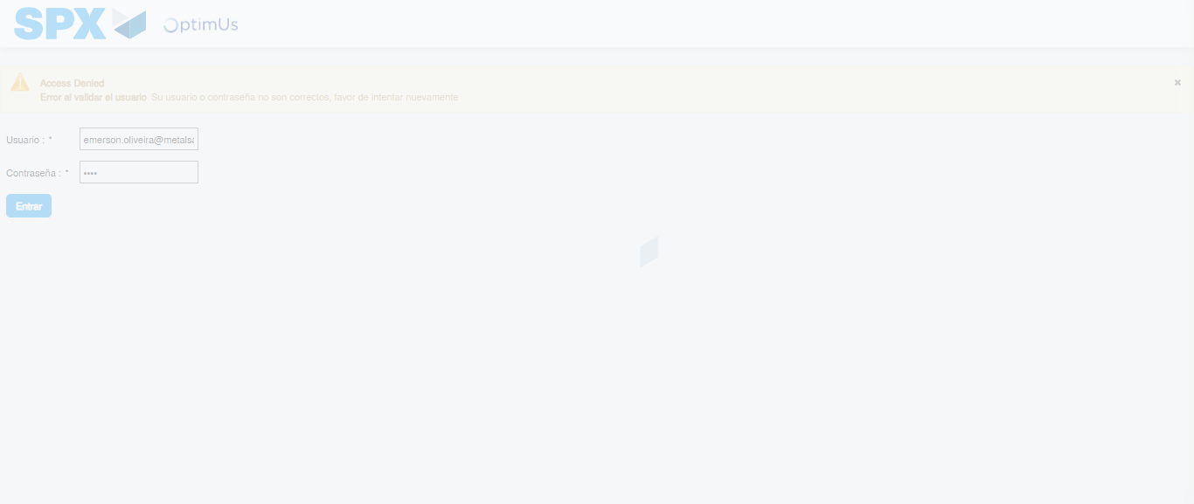Image file-name: QC_Testing-tc006_SPX_Dev5_Crear_Requisicion_Spot_Tipo_Cobro_Proyect_Urgent-1787009407710

Step 2 - Select to UEN and Access to Spot Buy Requisitions : UEN Correctly selected and Correct access
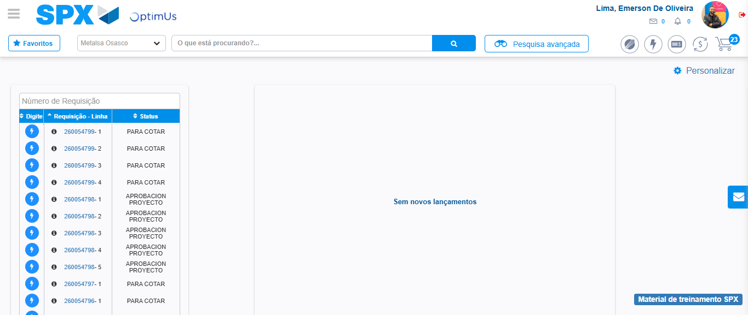Image file-name: QC_Testing-tc006_SPX_Dev5_Crear_Requisicion_Spot_Tipo_Cobro_Proyect_Urgent-1787009434706

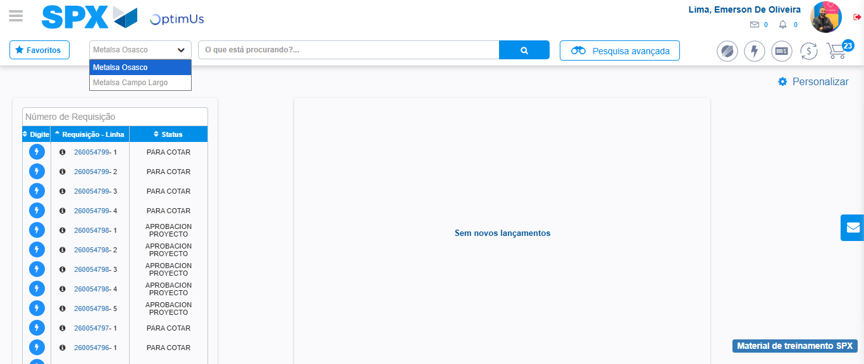Image file-name: QC_Testing-tc006_SPX_Dev5_Crear_Requisicion_Spot_Tipo_Cobro_Proyect_Urgent-1787009437282

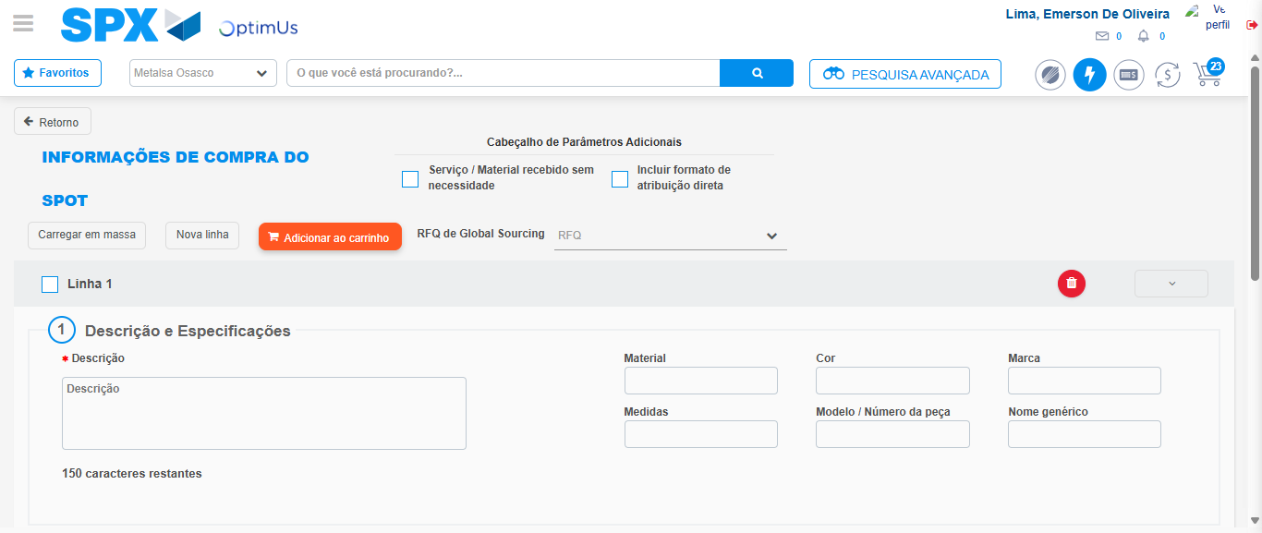Image file-name: QC_Testing-tc006_SPX_Dev5_Crear_Requisicion_Spot_Tipo_Cobro_Proyect_Urgent-1787009460931

Step 3 - Data Capture Spot Buy Requisition: Data captured correctly
Image file-name: QC_Testing-tc006_SPX_Dev5_Crear_Requisicion_Spot_Tipo_Cobro_Proyect_Urgent-1787009461268

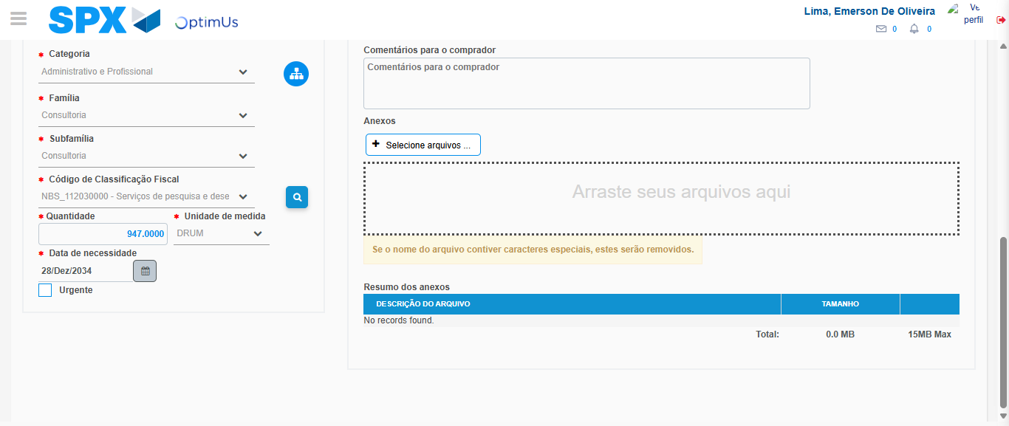Image file-name: QC_Testing-tc006_SPX_Dev5_Crear_Requisicion_Spot_Tipo_Cobro_Proyect_Urgent-1787009478347

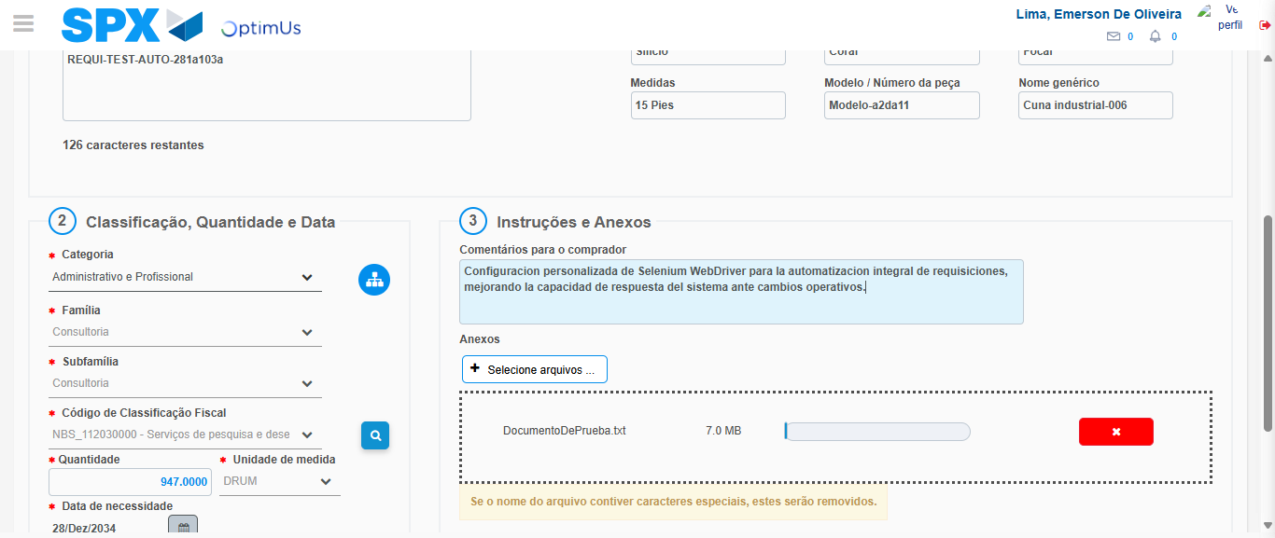Image file-name: QC_Testing-tc006_SPX_Dev5_Crear_Requisicion_Spot_Tipo_Cobro_Proyect_Urgent-1787009479264

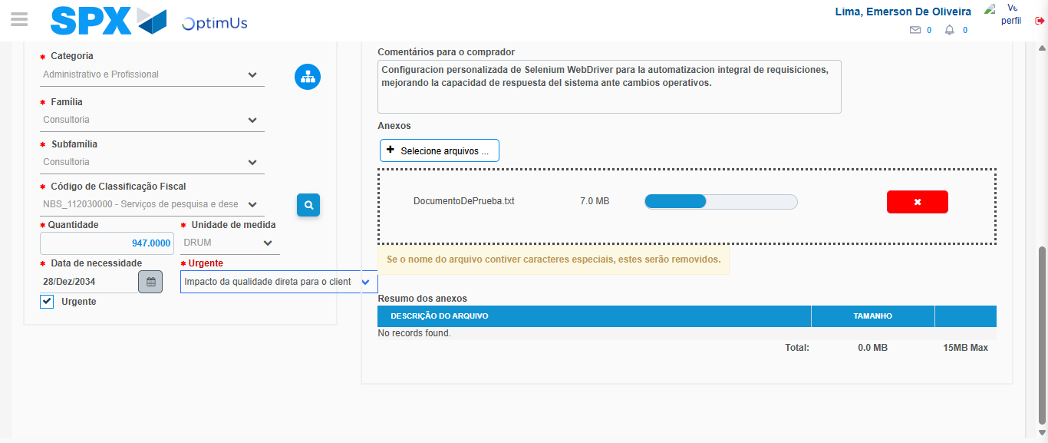Image file-name: QC_Testing-tc006_SPX_Dev5_Crear_Requisicion_Spot_Tipo_Cobro_Proyect_Urgent-1787009483186

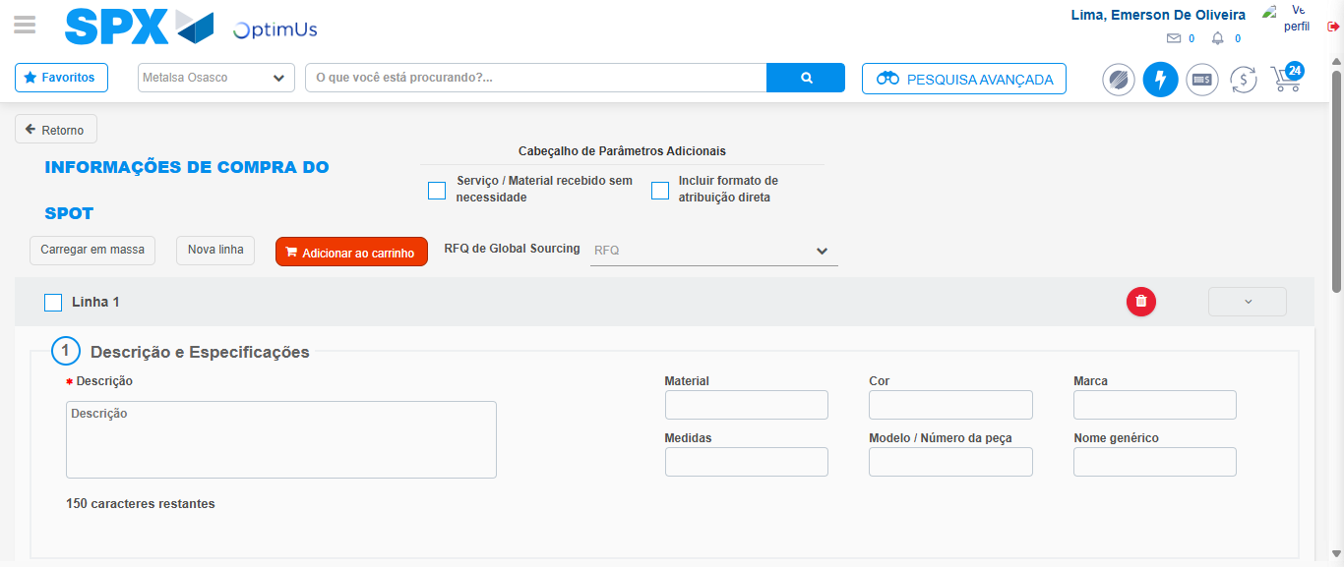Image file-name: QC_Testing-tc006_SPX_Dev5_Crear_Requisicion_Spot_Tipo_Cobro_Proyect_Urgent-1787009488205

Step 7 - Return to Main Page SPX : Return to Main Page SPX
Image file-name: QC_Testing-tc006_SPX_Dev5_Crear_Requisicion_Spot_Tipo_Cobro_Proyect_Urgent-1787009434706

Image file-name: QC_Testing-tc006_SPX_Dev5_Crear_Requisicion_Spot_Tipo_Cobro_Proyect_Urgent-1787009437282

Image file-name: QC_Testing-tc006_SPX_Dev5_Crear_Requisicion_Spot_Tipo_Cobro_Proyect_Urgent-1787009460931

Image file-name: QC_Testing-tc006_SPX_Dev5_Crear_Requisicion_Spot_Tipo_Cobro_Proyect_Urgent-1787009490475

Image file-name: QC_Testing-tc006_SPX_Dev5_Crear_Requisicion_Spot_Tipo_Cobro_Proyect_Urgent-1787009490695

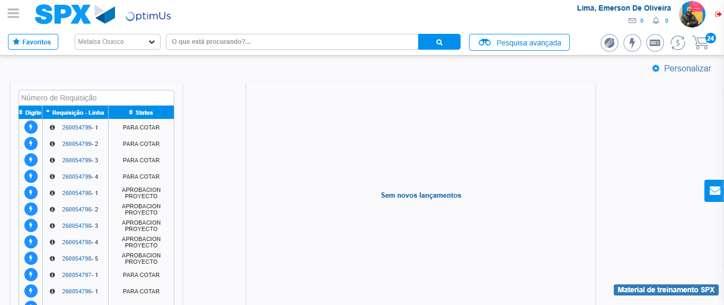Image file-name: QC_Testing-tc006_SPX_Dev5_Crear_Requisicion_Spot_Tipo_Cobro_Proyect_Urgent-1787009511843

Step 8 - Log Out : Log Out SPX
Image file-name: QC_Testing-tc006_SPX_Dev5_Crear_Requisicion_Spot_Tipo_Cobro_Proyect_Urgent-1787009512074

